Experiment No.- 1.3

|  |
| --- |
| Student Name: Prakhar Deep UID: 21BCS6353  Branch: CSE AIML Section/Group: AIML-7 (B)  Semester: 3rd Semester Date of Performance: 13-09- 2022  Subject Name: Python for machine Learning Subject Code: 21CSH-238 |

1. **Aim/Overview of the practical:**

Python program to check if a string is palindrome or not

1. **Steps for experiment:**
2. Start
3. Enter string as an input.
4. Using string slicing we reverse the string and compare it back to the original string
5. Then display the result
6. Exit
7. **Code:**

my_string=input("Enter string:")

if(my_string==my_string[::-1]):

  print("The string is a palindrome")

else:

 print("The string isn't a palindrome")

1. Output :

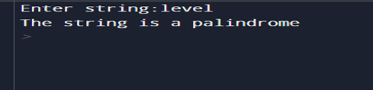

**Learning outcomes (What I have learnt):**

1. To grasp the basic concepts of the Python programming.

2. To implement & understand the various data types of python in a program.

3. To work with & import a library while designing a program.

4. To perform operations on a list as append in python.

5. To code & execute the cod on the Kaggle platform.

Evaluation Grid (To be created as per the SOP and Assessment guidelines by the faculty):

|  |  |  |  |
| --- | --- | --- | --- |
| Sr. No. | Parameters | Marks Obtained | Maximum Marks |
| 1. | Worksheet completion |  | 8 |
| 2. | Viva Voce/Quiz |  | 10 |
| 3. | Conduct of Experiment |  | 12 |
|  |  |  |  |